

CyberShield Solutions

Project Phase 3 Digital Marketing



March 26, 2025

ABDUL MOIZ (22I-1704) HUSSIAN KHAQAN (22I-1681)

AZAN AFZAL (22I-1741) FARUKH RIAZ (22I-1669)

Contents

**1.** **INSTAGRAM ACCOUNT** 2

**HOME PAGE** 2

**WEBSITE LINK** 2

**2.** **FACEBOOK ACCOUNT** 3

**HOME PAGE** 3

**WEBSITE LINK** 3

**3.** **LINKEDIN** 4

**HOME PAGE** 4

**WEBSITE LINK** 4

**4.** **OFFICIAL WEBSITE** 5

# **INSTAGRAM ACCOUNT**

## **HOME PAGE**

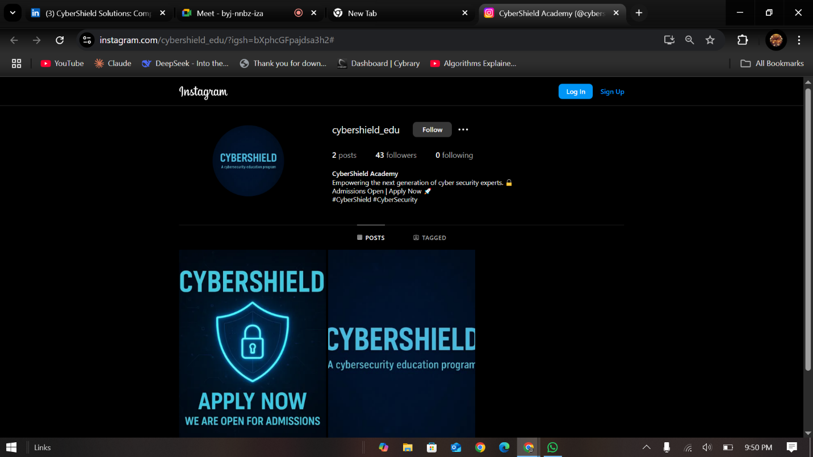

## **WEBSITE LINK**

[https://www.instagram.com/cybershield_edu/?igsh=bXphcGFpajdsa3h2#](https://www.instagram.com/cybershield_edu/?igsh=bXphcGFpajdsa3h2)

# **FACEBOOK ACCOUNT**

## **HOME PAGE**

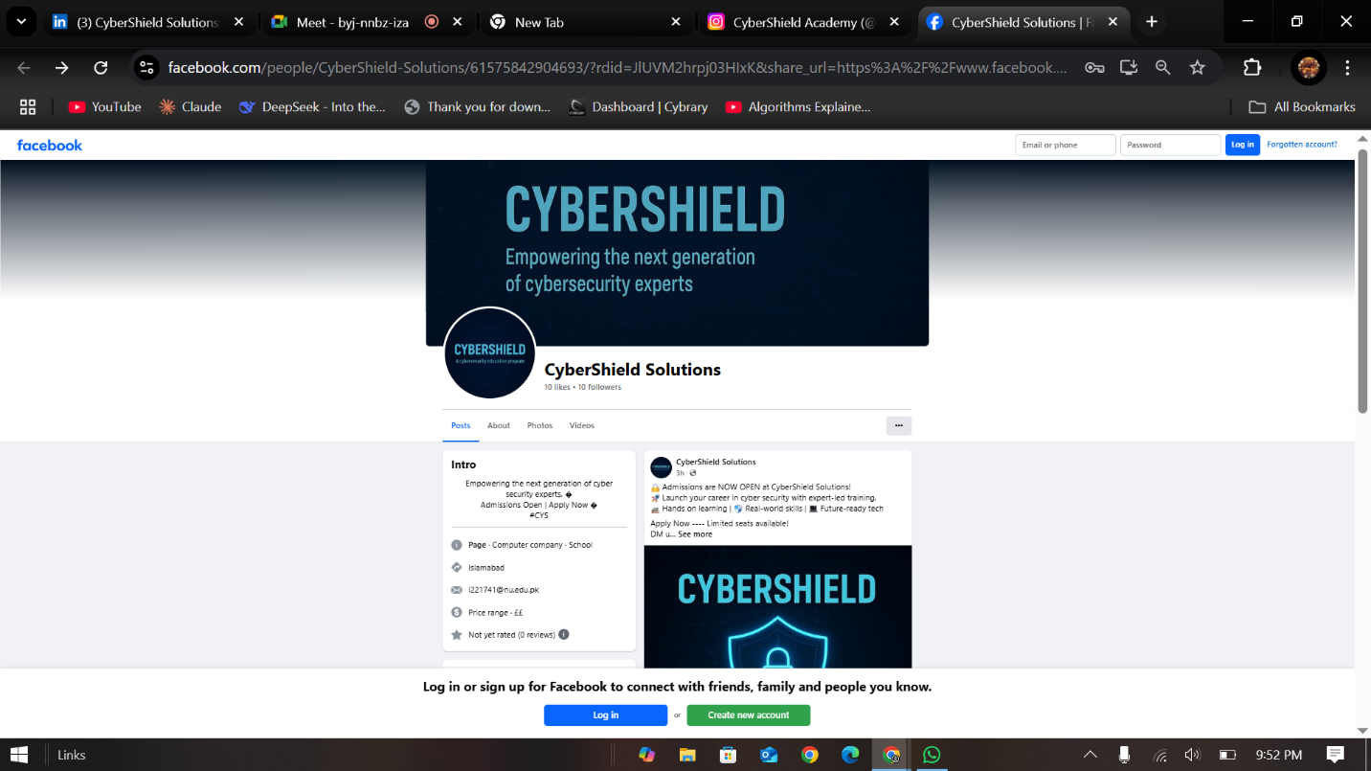

## **WEBSITE LINK**

<https://www.facebook.com/share/163CpQ1Q6L/>

# **LINKEDIN**

## **HOME PAGE**

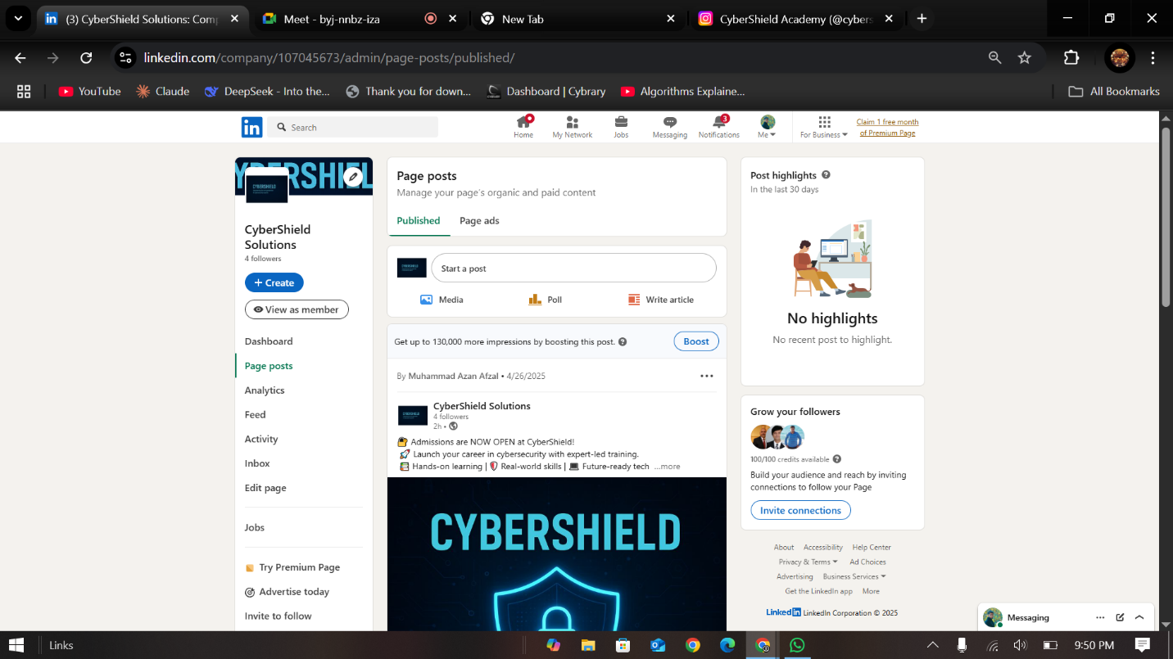

## **WEBSITE LINK**

<https://www.linkedin.com/company/cybershield-solutions/?viewAsMember=true>

# **OFFICIAL WEBSITE**

